Question 2

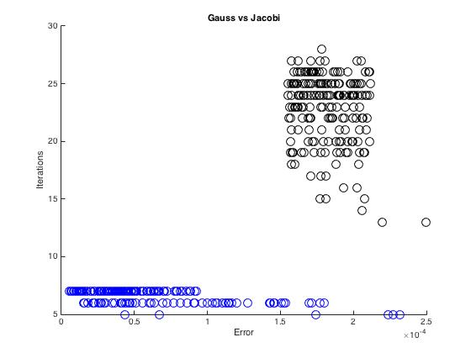

average error of Gauss = 5.1294e-06

average error of Jacobi = 2.3022e-05

ratio = 3.4099

From the graphs, it's clear that the Gauss-Seidel iterations took less iterations to reach the tolerance than Jacobi iterations. The larger the error between the initial vector and the exact vector, the less iterations were required. The largest eigenvalue of the iteration matrix dictates the rate of convergence for jacobi and gauss-seidel. The reason for the ratio between jacobi and gauss-seidel is constant is due to the largest eigenvalue not changing.